**[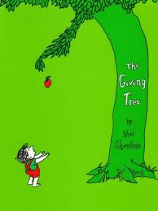](http://www.google.com/imgres?q=the+giving+tree&um=1&hl=en&safe=active&sa=N&rlz=1R2ADFA_enUS369&biw=1024&bih=540&tbm=isch&tbnid=7Y9Of_CPUb0DwM:&imgrefurl=http://youarewhatyouread.scholastic.com/adults/books/show/the-giving-tree-shel-silverstein&docid=Bz2kpXR1u29tgM&imgurl=http://content.scholastic.com/yawyr/89c21f10fcde7fb34894be626f2f683c128c1d0b.jpg&w=486&h=652&ei=WXatT8PuMoao0AG-6pmZDA&zoom=1&iact=hc&vpx=441&vpy=144&dur=531&hovh=260&hovw=194&tx=144&ty=195&sig=105606283059644955069&page=1&tbnh=115&tbnw=94&start=0&ndsp=14&ved=1t:429,r:3,s:0,i:86)Basic English: Summer Reading Packet**

**The Giving Tree by Shel Silverstein**

1. **Be prepared to read out loud the story to Mrs. Steinmetz the first week of school. See attached for grading rubric. Visit the following websites to have the story read to you**

* <http://dilayllah.wordpress.com/2007/11/18/the-giving-tree-story/>

OR

* Type “The Giving Tree Shel Silverstein” into the search at: [www.youtube.com](http://www.youtube.com)

(<http://www.youtube.com/watch?v=1TZCP6OqRlE&feature=related>)

1. **Complete the packet and turn it in the first day of school.**

**Vocabulary: Use a dictionary or use your computer and go to:** [**http://translate.google.com/#**](http://translate.google.com/) **to translate the following words**

|  |  |  |
| --- | --- | --- |
| **Word** | **Translation into your language** | **Picture** |
| **Tree** |  |  |
| **Gather** |  |  |
| **Leaves** |  |  |
| **Crowns** |  |  |
| **Forest** |  |  |
| **Climb** |  |  |
| **Trunk** |  |  |
| **Swing** |  |  |
| **Branches** |  |  |
| **Sleep** |  |  |
| **Shade** |  |  |
| **\*Alone** |  |  |
| **Money** |  |  |
| **Sell** |  |  |
| **Carried (past of carry)** |  |  |

|  |  |  |
| --- | --- | --- |
| **Word** | **Translation into your language** | **Picture** |
| **Happy** |  |  |
| **Stayed (past of stay)** |  |  |
| **Sad** |  |  |
| **Busy** |  |  |
| **House** |  |  |
| **Wife** |  |  |
| **Children** |  |  |
| **Build** |  |  |
| **Cut** |  |  |
| **Whispered (past of whisper)** |  |  |
| **Old** |  |  |
| **Boat** |  |  |
| **Far** |  |  |
| **Trunk** |  |  |
| **Sail** |  |  |
| **\*Nothing** |  |  |
| **\*gone** |  |  |
| **Teeth** |  |  |
| **Sighed (past of sigh)** |  |  |
| **Quiet** |  |  |
| **Tired** |  |  |
| **Rest** |  |  |

**Now put all of the vocabulary words into the correct column. DO NOT include the three words that have an * asterisk next them.**

|  |  |  |
| --- | --- | --- |
| **Noun (person, place or thing)**  **14 nouns** | **Verb (action word)**  **13 verbs** | **Adjectives (describes a noun)**  **7 adjectives** |
| 1.Tree  2.  3.  4.  5.  6.  7.  8.  9.  10.  11.  12.  13.  14 | 1.gather  2.  3.  4.  5.  6.  7.  8.  9.  10.  11.  12.  13 | 1.happy  2.  3.  4.  5.  6.  7. |

**The Giving Tree: Idea Web**

**First write the names of three people who you know and how you know them (mother, father, sister, etc.) in the arrow. Then write a sentence next to it as to how they are giving to you.**

**People who are giving to me**

____________________

They give me _______________

____________________

They give me ________________

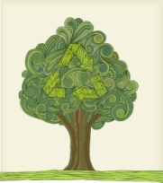

____________________

They give me _______________

____________________________________________________________

**First write the names of three people who you think you should be more giving to and how you know them (mother, father, sister, etc.) in the arrow. Then write a sentence next to it as to how you can be more giving to them.**

**How I can be more giving**

____________________

I can give them _______________

____________________

I can give them_______________

C:\Documents and Settings\mkhalil\Local Settings\Temporary Internet Files\Content.IE5\LTOMQD9T\MC900057566[1].wmf

____________________

I can give them ______________

**Story Sequencing**

**Copy the sentences that are located on the back of this page in the correct order below. Start with the title of the story.**

1. _______________________________________________________
2. _______________________________________________________
3. _______________________________________________________
4. _______________________________________________________
5. _______________________________________________________
6. _______________________________________________________

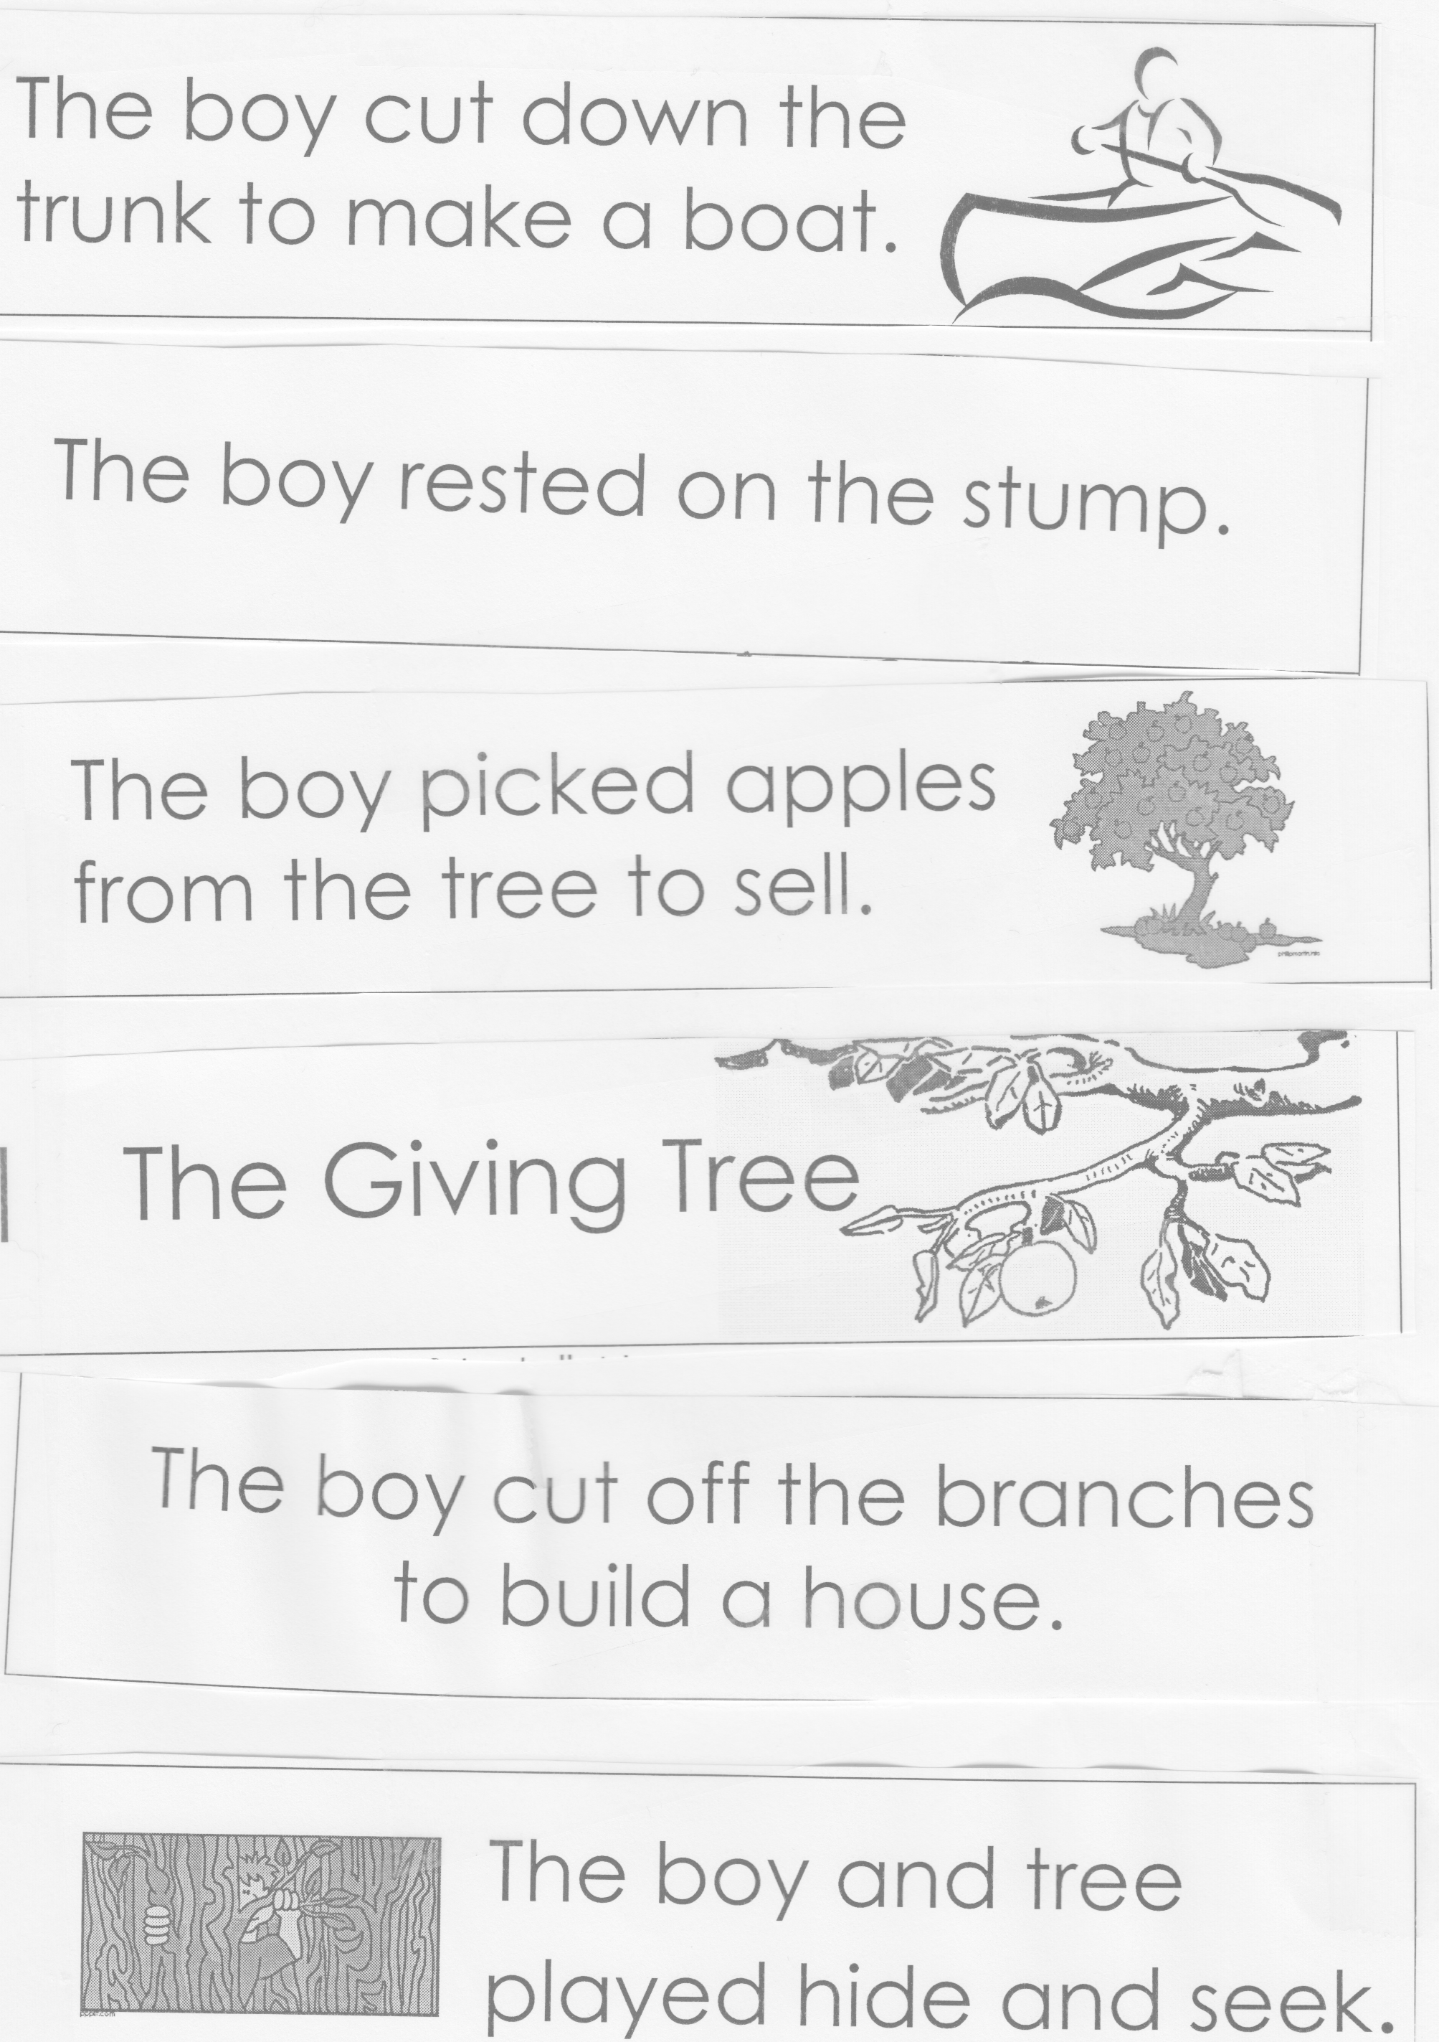**Storytelling Rubric Grade**

|  |  |  |  |  |
| --- | --- | --- | --- | --- |
|  | **1** | **2** | **3** | **4** |
| **Confidence** | Not that confident in themselves | Somewhat confident and sure of themselves | Mostly confident and sure of themselves | Very confident and sure of themselves |
| **Seriousness** | Did not take the project that seriousness | Somewhat took the project serious | Mostly took the project serious | Took the project serious and did not laugh inappropriately |
| **Pronunciation X2** | Pronounced the story 25% or fewer correctly | Pronounced 50 % of the story correctly | Pronounced 75% of the story correctly | Pronounced all of the story correctly |
| **Rate** | Spoke way too fast or too slow | A lot of spots of the story were told too fast or too slow | Some spots of the story were told too fast or too slow | Spoke at a good rate; not too fast and not too slow |
| **Sound** | Couldn’t hear some of the story and mumbled the words | Somewhat able to hear the story well | Mostly able to hear the story well | Was able to hear the story well |

**Total Points: ______________/ 24 points**